

LEARNING MANAGEMENT SYSTEM :

Submitted by
Zubia Hameed
(F22BINFT1E02139)
7th semester 1E
Submitted to
Ma'am Sara Fareed

Department of Information Technology
The Islamia University of Bahawalpur

Software Requirement Specification

Introduction

Everything nowadays is moving forward and merging themselves with technologies to accelerate their performance in the market efficiently. Same way, the education sectors are also engaging with different advance technologies for their management. Learning Management System is playing a very major and important role in the field of education to manage things more professionally in less time without headache. This development journey encircles the creation of a dynamic, user-friendly platform that not only centralizes educational resources but also fosters engagement, assessment, and continuous improvement among them.

1.2 Project Overview Statement

In our educational landscape, the need for an advanced Learning Management System (LMS) has become important. Our proposal, "Learning Management System" addresses this importance by introducing a cutting-edge LMS tailored to meet the dynamic needs of modern educational institutions. Our LMS streamlines administrative tasks, ensuring teachers & faculty can focus on teaching, not paperwork. This project focus on innovation, drawing on my team's extensive experience in educational technology. With a focus on efficiency, personalization, and innovation, our project seeks to provide teachers and students alike with a cutting-edge platform that not only simplifies administrative processes but also enhances the overall educational experience. The LMS will serve as a comprehensive platform for educational institutions, instructors, and students to interact, collaborate, and engage in a virtual learning environment without facing any difficulties. It will feature user-friendly interfaces, content management capabilities, and different tools to foster dynamic and interactive learning experiences. The LMS will prioritize intuitive navigation and user experience, ensuring that both teachers and students can easily access and utilize its features. The LMS will incorporate data analytics capabilities, enabling faculty to gain insights into student performance and engagement, thereby facilitating data-driven instructional improvements. This component collects and analyzes data on user activities, course engagement, and learning outcomes. It generates reports and insights to assist instructors and administrators in making data-driven decisions.

  - Project Goals & Objectives:

In this section, we outline the goals and specific objectives of our LMS project. It's important to differentiate between goals, which set the broader context and purpose, and objectives, which define measurable outcomes and guide our project's activities.
Project Goals:

The goals represent the high-level aspirations of our LMS project, setting the stage for what we aim to achieve. They provide the overarching vision and context for our efforts.

Enhance Educational Experience:
- Create an LMS that significantly enhances the overall educational experience for students, instructors, and administrators.
- Foster engagement, efficiency, and improved learning outcomes.

User-Friendly Interface:
- Develop an intuitive and user-friendly interface that facilitates easy navigation and accessibility.

Comprehensive Course Management:

- Implement robust course management features to empower instructors in creating, managing, and delivering courses effectively.

Learning Management System

Software Requirements Specifications
Functional Requirements

No | Requirement | Description
FR1 | Semester System | The LMS can create a new semester for offering. The semester is automatically offered to students when the Semester Registration Start Date is reached. The following information will be needed:  - Year  - Type (Spring, Summer, Fall)  - Semester Start Date  - Semester End Date  - Semester Registration Start Date  - Semester Registration End Date  - Course Registration Start Date  - Add Course Last Date  - Drop Course Last Date  - Withdraw Course Last Date  - Classes Start Date  - Classes End Date
FR2 | Offer Course | The Administration will set up the desired course for a semester depending upon FR1. The course will contain all the subject for the current active semester.
FR3 | Add Student to Course | When a student’s requests to add a course, the system will check the number courses that the student is already registered in and student’s GPA against the requirement of the course. For BS and MS, maximum limit of courses in a semester is 6. The system will then check for clashes between the registered courses and the new course.

FR4 | View reports | The various types of reports that the users (depending on their access level and role) can view are:  - Course-wise Registration (specifying sections)  - Student-wise Registration (specifying sections)  - Waiting List of that Course (specifying sections)  - Date-wise Add/Drop status of each student
FR5 | User Management | - Authorization/ Registration  - Add User  - View the list of Users  - View User profile information  - Edit User profile information  - Delete User  - Archive/ Unarchive User  - Manage User’s rights  - View User dashboard
FR6 | Events | - View the list of Events  - Create new Event  - Event Edit  - Event Delete

FR7 | Semester Freeze | A student can freeze his next or previous semester by paying the required amount to Accounts. The fee has to be paid for each semester (maximum 2) that is to be frozen. The current semester cannot be frozen if a student is taking courses.
FR8 | Clear Accounts Status | The Accounts Officer can clear the status of a student when he pays his dues.  When the student pays his dues or submits the financial aid/installments application, the Accounts Officer clears his financial status so that the student’s seat can be confirmed.  When the student pays his semester freeze dues the Accounts Officer does the same.

Non-Functional Requirements

No | Requirement | Description
NFR1 | Security | - All access to the system will be logged.  - Only an administrator shall be able to create users.  - Only authorized and authenticated users shall be able to access the system i.e. a user with valid username and password and the right post/domain.  - System operators shall not have access to the data that they do not need  - Database shall be accessed indirectly using predefined queries so that there is no direct SQL injection attack i.e. the user information that may affect the queries generated for the system or corrupt database  - Illegal operations may lead to termination of program. Error handling and exceptions will stop any illegal operations.
NFR2 | User Interface | Internet explorer 6.0+ will work as the client application on Windows.
NFR3 | Platform Independence | The system will be independent of a single platform and commercial software.
NFR4 | Extensibility | The system will be extensible and modular to integrate with other automated systems as they are developed

NFR5 | Performance | The system will be able to handle multiple requests over the Intranet of 50 users at the maximum.  When the applicant submits his information, the maximum delay before getting a response shall not exceed 3 minutes  The availability of the application form shall be 24 hours a day during the dates it is uploaded on the site.  The response time experienced by the administrator while editing or uploading the application form shall not be more than 30 seconds.  Accuracy of up to 4 decimal places shall be provided while generating reports  The software shall produce reports on the data saved in the database. Therefore, the software has the capacity to generate reports of any size that is within the database limits.  After a training of 1 hour of an experienced computer user, the average number of mistakes made by any system operator shall not exceed 1 per day
NFR6 | User Documentation | Online help shall be made available for:  - The applicants to help them in following the application procedure.  - The candidates giving the test to guide them through the instructions at the start of the test.  - Reference manual shall be provided for all system operators defining user interfaces and functionalities provided by each interface to assist them in making use of the functionalities provided.  - Installation manual shall be provided to the system users.  - Recovery manual shall also be provided to assist them in case of system failures.

Use Case Diagram

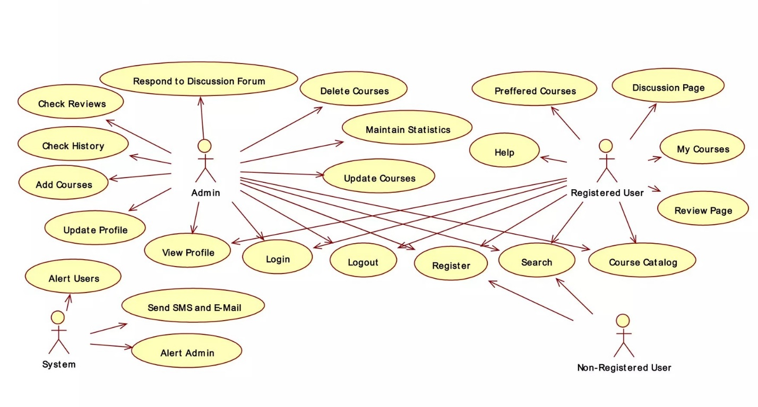

Interface Design
The Architecture Diagram is like a map that shows the overall structure of our LMS. It displays the main components (like servers, databases, and user interfaces) and how they connect. This diagram helps us visualize the high-level design and understand the flow of information within our system.

3.3 Use Case Descriptions

Now, let's zoom in and look at the details. Use Case Descriptions give us a closer view of each use case, almost like reading a scene from our LMS story.

3.3.1 Use Case Name

This is just the title of our 'scene' – the name of the action we're looking at.

3.3.2 Actors Involved

Who are the main characters in this scene? This tells us which actors will be doing something in this use case.

3.3.3 Description
A short story or explanation of what happens in this scene. It helps us understand the purpose of the use case.
3.3.4 Preconditions

What needs to be true or set up before this scene can happen? It's like the background information we need.
User Feedback and Iterative Development:

Emphasize the importance of collecting user feedback and incorporating it into future development cycles. Iterative development ensures the continuous improvement of the LMS based on real-world usage. By concluding the LMS project with thoughtful reflection and outlining future possibilities, this chapter provides a comprehensive view of the journey from inception to completion. It sets the stage for ongoing improvements and developments, ensuring the LMS remains a dynamic and effective tool for education and training

